# The Pinto and the Tesla

It is hard to imagine two cars further apart from each other than the Ford Pinto and Tesla Motors’ Model S (or take Model X or 3 – the discussion works with any of these). The former is synonymous with the bad designs and sub-standard manufacturing that became the hallmark of Detroit’s ‘affordable cars’ in the seventies and eighties. The latter is a testament to how high-tech designs and advanced production can be married into a space-age, ultra-luxury vehicle for this digital world. Running on gasoline, the Pinto possessed not a single integrated circuit outside of its sound system, and the very idea of onboard computer control was laughable at the time of its launch. Powered by state-of-the-art electric batteries, Tesla vehicles have sophisticated computer controls that enable adaptive lighting, self-parking, and a host of other perks as every-day features.

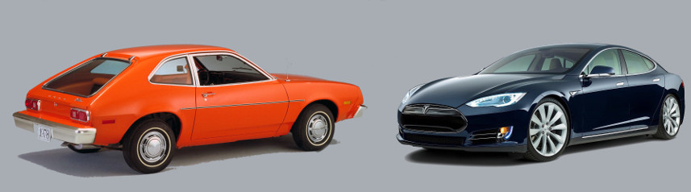

And yet, there is one very disturbing commonality between them that transcends the mere similarity that both are four-wheeled motor vehicles. Both cars will go down in history as object lessons on the danger of withholding safety information from the marketplace. Before exploring this topic, I want to make it clear that I am not implying that the Tesla is unsafe, nor am I asserting that the Pinto was, either. As I hope to make clear below, it isn’t even clear how to define what unsafe means. Rather, the central point is whether each manufacturer, Ford and Tesla, worrying about how the safety of their vehicles would be perceived, actually hid relevant information from the marketplace.

Each of us can relate to the concept of concealing embarrassing or unflattering information from the world around us. When it comes to our personal lives, each of us is entitled to a degree of privacy. But even this cherished concept has limits. Is it reasonable to be able to hide every fact of our private lives from an employer? Doesn’t the employer, who is buying our labor, have a right to know if there are any outside issues that will compromise our ability to deliver? Likewise, don’t we have a right to know certain facts about the people for whom we will work? Wouldn’t you like to know if your boss has had a history of embezzlement or sexual harassment?

The situation is even more pronounced when talking about a product or good. When contemplating buying a product, the consumer should be able to make an informed decision about what the product can do for the price required to procure it versus the risk; what it can’t do, what its limitations are, how reliable it is, how soon it will break, and so on. In economic terms, what we are talking about is the need to have relevant information in order to be able to adequately judge cost versus benefit risk. The need to mitigate risk with limited information is a major driver in economics decision making, even if the abstract theory is not well understood.

It is the idea of being well-informed, of having all the relevant information, that goes to the heart of both the Pinto and Tesla in their presentation to the public.

## The Pinto

[The Ford Pinto](https://en.wikipedia.org/wiki/Ford_Pinto) was a subcompact car that was sold for model years 1971-1980. While comparable in design and safety to its contemporaries in its class (in fact having a better safety record than most), the Pinto achieved a distinction in automotive history that the others failed to capture – it became known, ever after, as an ‘evil car’ that was a ‘fire trap’, and Ford, at the time, was perceived as a callous car company that put profit over human life. These verdicts resulted from the confluence of three factors (taken from the Wikipedia article and the factual summary provided in [*The Myth of the Ford Pinto Case*](http://www.pointoflaw.com/articles/The_Myth_of_the_Ford_Pinto_Case.pdf), by Gary T. Schwartz).

First, during their design of the Pinto, Ford Engineers decided to put the fuel tank behind the rear axel rather than on top of it. This was a conscious decision made to afford the consumer more trunk space. The trade-off was that the fuel tank was prone to rupture in the event of a rear-end collision, causing a fire hazard to the occupants. The risk of tank rupture was increased by other design decisions that limited the size of the ‘crush space’ and significantly reduced mechanical structure that would have provided reinforcement to the space surrounding the gas tank.

Second, a tragic case occurred in May 1972 when Lily Gray gave a ride in her Pinto to her teenage neighbor Richard Grimshaw. The car stalled in a highway lane and was rear-ended. Gray died due to the crash and subsequent fire, and Grimshaw suffered horrible injuries. The Grimshaw family subsequently sued Ford, and the resulting discovery revealed documents that put Ford into a bad light.

Third, public opinion was significantly molded and shaped by an article that appeared in the September/October 1977 issue of *Mother Jones* entitled [*Pinto Madness*](http://www.motherjones.com/politics/1977/09/pinto-madness) by Mark Dowie. The article starts with the inflammatory accusation

<For seven years the Ford Motor Company sold cars in which it knew hundreds of people would needlessly burn to death – Mark Dowie>

This article turned public opinion very strongly against the Pinto and led to the National Highway Traffic Safety Administration (NHTSA) demanding Ford recall the Pinto despite the fact that years earlier NHTSA had concluded that there was not enough information to warrant even opening an investigation.

What swayed public opinion and cemented the legacy of the Pinto were internal memos from Ford that seemed to paint the picture that Ford thought it would be cheaper to pay settlements to those killed and injured than it would be to retool the factories to make the car safer. This led Dowie to say

<Ford waited eight years because its internal “cost-benefit analysis,” *which places a dollar value on human life*, said it wasn’t profitable to make the changes sooner. – Mark Dowie>

In contrast to Dowie’s outrage over cost-benefit analysis, Gary T. Schwartz, in his article, entitled [*The Myth of the Ford Pinto Case*](http://www.pointoflaw.com/articles/The_Myth_of_the_Ford_Pinto_Case.pdf), remarks that

<…the standard public policy analysis of products liability calls on manufacturers, first of all, to design products in risk-beneficial ways, and secondly to advise consumers of non-obvious hazards that remain in a product’s designs once those risk-benefit decisions are rendered.>

Schwartz also goes on to note that

<[T]he case shows how disturbed the public can be by corporate decisions that balance life and safety against monetary cost. This disturbance suggests an apparent mismatch between public opinion and the assumptions underlying the risk-benefit test for design liability. … In any event, the public’s dissatisfaction with the practice of confidential corporate risk-benefit balancing highlights the appropriateness of thinking about the Pinto case in terms of the manufacturer’s duty to warn.>

In short, the Ford Pinto was done-in more by the perception that Ford withheld vital information than by the actual risk the car posed to its occupants.

## The Tesla

Fast forward nearly forty years. While the technology may have changed, the human equation has not. This time the issue of withholding vital information from the marketplace falls squarely on the Tesla Motor Company. At issue is again a perception of safety and what responsibilities the manufacturer has to warn its customers.

To set the stage, we need to step back a bit to the fall of 2014. In an article dated October 9, [CNET’s Wayne Cunningham gushes over the new features of the Model S](Tesla's%20electric%20Model%20S%20has%20proven%20a%20very%20technically%20advanced%20car,%20except%20in%20regard%20to%20driver-assistance%20systems.%20All%20that%20changes%20now,%20as%20Tesla%20Motors%20CEO%20Elon%20Musk%20announced%20at%20an%20event%20in%20Los%20Angeles%20that%20every%20car%20manufactured%20over%20the%20last%20two%20weeks%20comes%20with%20new%20sensor%20hardware%20to%20enable%20what%20he%20calls%20Autopilot%20capabilities.), in particular, the set of advanced driver assistance features that enable adaptive cruise control and lane keeping assist. Cunningham notes that each Model S bears a forward-looking radar and camera and panoramic ultra-sonic sensors that enable the vehicle to ‘see’ speed limit signs and follow ‘curvy’ lane lines. Tesla Motors branded this new feature [Autopilot](https://www.tesla.com/models), which, according to their website,

<… allows Model S to steer within a lane, change lanes with the simple tap of a turn signal, and manage speed by using active, traffic-aware cruise control. Digital control of motors, brakes, and steering helps avoid collisions from the front and sides, and prevents the car from wandering off the road. Autopilot also enables your car to scan for a parking space and parallel park on command. And our new Summon feature lets you "call" your car from your phone so it can come greet you at the front door in the morning. – Tesla Motors>

All this advertising sounds great but the fly in the ointment came about 18 months later, when [on June 30, 2016, Tesla revealed that someone had lost their life in a traffic accident on May 7th with Autopilot enabled](http://www.theverge.com/2016/6/30/12072408/tesla-autopilot-car-crash-death-autonomous-model-s).

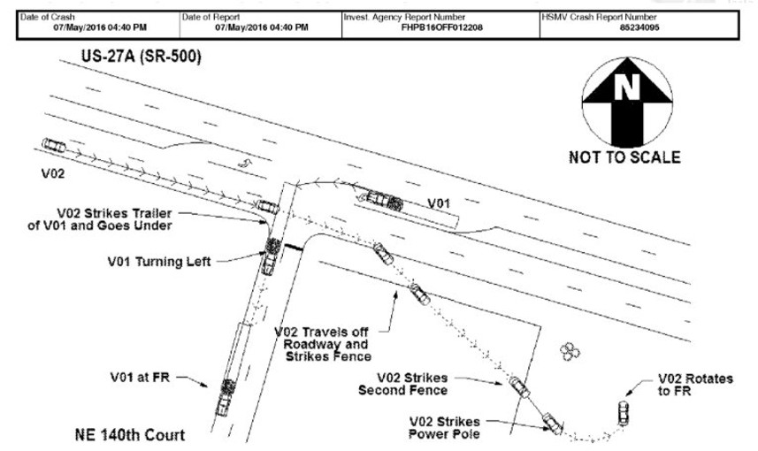

The news reaction, while so far more measured than the Mother Jones piece on the Pinto, still sought for the sensational angle. For example, consider the opening paragraphs in the article [*What Tesla Autopilot crash means for self-driving cars*](http://www.usatoday.com/story/money/cars/2016/07/17/what-tesla-autopilot-crash-means-self-driving-cars/87219126/) by Greg Gardener

< This summer, autonomous cars collided with reality.

All those sensors and cameras and spinning cylinders of laser beams don't know as much as we thought they did. At least not yet. >

And like the Pinto case, there are competing explanations for the accident. According to a report by the Associated Press, the [fault in the crash lies with the car’s cameras](http://www.foxnews.com/leisure/2016/07/01/tesla-driver-using-autopilot-feature-killed-by-tractor-trailer/) being unable to distinguish the white tractor trailer with which it collided from the brightly lit sky behind. Another report suggests that the [radar system on the Autopilot is tuned to disregard overhead signs](http://phys.org/news/2016-07-tesla-autopilot-radar.html) and that, as a result, its input to the autonomous decision-making was disregarded even if it had sensed the truck. When questions of liability are involved, there is likely to be no end of speculation and controversy.

As a result of the accident, Tesla Motors is being investigated by three government agencies: The National Highway Traffic Safety Administration (NHTSA), The National Transportation Safety Board (NTSB), and the Security and Exchanges Commission. NHTSA’s involvement is natural. NTSB’s involvement, while a bit out of the ordinary, is reasonable since NTSB seems to be keeping its eye on autonomous driving features being developed. The reason for the SEC being involved smacks of the ‘profit before people’ angle that reared its head in the Pinto case. [Tesla and Musk are being investigated for insider trading](http://www.businessinsider.com/sec-investigating-tesla-possible-violation-securities-law-2016-7) because they failed to report the fatality on May 7th before they sold $2 billion in stock on May 18th.

As these various threads weave together to form a tapestry, it will be interesting to see just where the line is drawn on what Tesla should have told its investors and its customers and when. Their advertising copy certainly makes Autopilot sound bulletproof. They don’t warn the consumer of its limitations; and not just the ones being attributed as the core causes to the May 7th accident. As far as I can tell, Tesla does not point out that Autopilot can’t keep the vehicle in a lane on a road with no lane markings. Many of the back roads and small highways in the nation don’t have clear markings and how Autopilot will respond in these cases is unknown. Of course, the more Tesla points out these limitations the less appealing Autopilot will seem. So where is the balance between too much and too little information to be struck? Only time will tell.

# New Universe – Part 1: Rise and Fall

July 22nd, 1986. The day of the White Event. The day when the world changed. That’s it! That’s the answer. Build a consistent universe from the ground up for the discerning comics reader. A universe as real and nuanced and believable as the world just outside their window. Thus began the [New Universe](https://en.wikipedia.org/wiki/New_Universe).

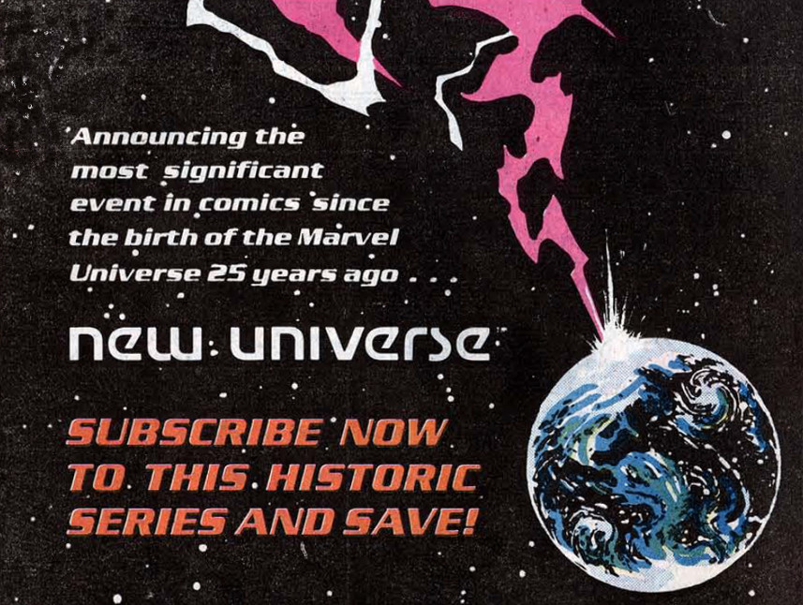

The brainchild of Jim Shooter, the New Universe concept promised a wholly independent playground that would be launched to celebrate Marvel’s 25th anniversary. In Jim Shooter’s own words, the New Universe

<…started, about 2 1/2 years before our 25th anniversary, we had a staff meeting of all the vice presidents to talk about what we were going to do for it. Some ideas were bandied around.

So somebody said, "Look, this is an anniversary of a publishing event." "Well," I said, "there are two possibilities. You could start everything over from number one, like the Marvel universe reborn. Like the anniversary in May or June, all the titles wrap up the month before and start again the next month. Sort of like Marvel, 2nd edition, do it right and really make that spectacular." ... We were selling incredibly well so it wouldn't be a good idea to derail the train.

So I said, "Then let's celebrate the birth of a universe with the birth of another universe."

I walked out of there with a development budget of about $120,000 and I'd create eight titles. It was money to spend on research, sketches, things like that.>

And so eight titles were launched: *D.P. 7*, *Jvstice*, *Kickers Inc.*, *Mark Hazzard: Merc*, *Nightmask*, *Psi-Force*, *Spitfire and the Troublemakers*, and *Star Brand*. (Note: I know that the ‘purists’ will point out that Jvstice should actually be spelled Justice after the name of the character but the covers clearly show a ‘v’ in place of a ‘u’ and that’s the convention I’ll follow).

The idea was to make a science based universe, free of mythical figures, undiscovered worlds, and farcical technology. The intention was to create something much closer to hard science fiction than to fantasy. To follow the rules of a world similar to the real one but with the extra component of some people having super powers.

Unfortunately, it was obvious from the start that there was a lot wrong. The initial launch was behind schedule, the production value of the books was generally poor, and the writing was often not consistent with the premise. As time went by, some of it got better and some of it got worse. By the end of the first year, half the books were cancelled, one had been downgraded to bi-monthly and three continued on. These were supplemented by three graphics novels: The Pitt, The Draft, and the War. All told the New Universe lasted about 3 years.

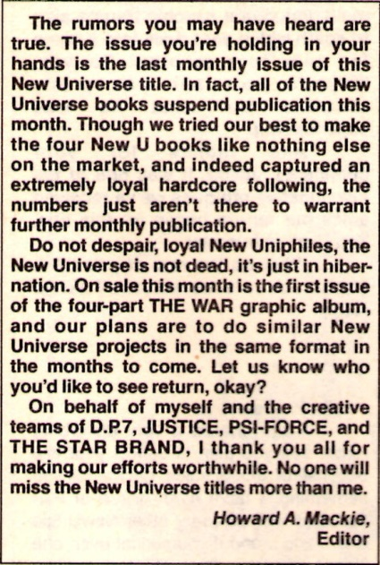

The reasons for the failure seem to be firmly rooted in the usual cause of such things – the human condition. Creators seemed to think that they had free-reign to go off in any direction they want. Corporate and business types seemed to be very worried about the non-reoccurring costs of creating a new publishing line. Budgets were cut, schedules delayed and so on. Ironically, the drama surrounding the rise and fall of the properties make for much better stories than most of the fictional ones told during the initial publication run. That said, this column will not be dealing with the business side of this short-lived endeavor but rather will critique the stories themselves. The reader is encouraged to read the [Comic Book Resources interview with Jim Shooter](http://www.comicbookresources.com/?page=article&id=147) for more background on the corporate situation at Marvel during that time.

Interestingly, despite the initial failure of the line, the stories seemed to have resonated in some fashion with the fan base. Its influence went beyond its 3-year life, shaping a variety of Marvel properties over the following decades. The characters of the New Universe were revisited several times after the collapse and a variety of new stories were told, including the *Untold Tales of the New Universe*

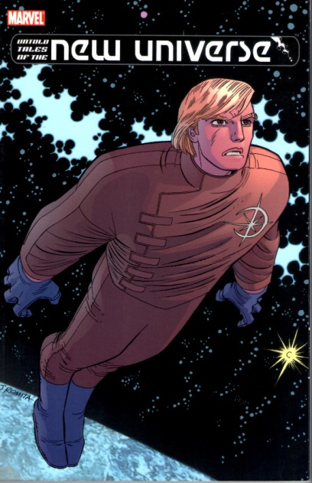

and an imaginative effort by Mark Gruenwald, which brought the NU characters into the Marvel multiverse and into direct contact with the central Marvel universe. And the NU concepts have had surprising longevity with aspects, like superflow, and characters, like Starbrand and Nightmask, figuring prominently into the recent *Everything Dies/Secret Wars* storyline.

## Background and Structure

The central idea of the New Universe (NU) is the idea of the White Event, a singular astronomical phenomenon that is responsible for the creation of the generation of superpowers amongst the Earth’s population. While neither the root cause nor the full effect of the White Event was explained initially, as the line evolved it was ‘revealed’ that the White Event was directly connected to the titular character of the Star Brand book and that the percentage of humans altered was relatively low. These altered humans were collectively called paranormals.

When first launched, it was clear that each book was independent of all the others – often embarrassingly so. Whether due to creative differences or the fact that much of the initial NU work was done on a volunteer basis due to budget, Shooter’s vision didn’t take hold with much of the creative staff. The first issues of *Spitfire and the Troublemakers* and *Jvstice* gave particularly egregious violations of the idea that the universe would be more thoughtful and science-based and less fantastic.

*Spitfire and the Troublemakers* followed the extracurricular activities of a genius professor at MIT and her four precocious students. There seemed to be nothing the latter couldn’t do, including inventing advanced robotics, rapidly fixing technology they had never seen or studied, and knowing how to drive a 18-wheeler. One wondered why they were even at MIT instead running their own businesses or starting their own universities. Indeed, where did they manage to find the time to attend class in between having adventures here, there and everywhere?

*Jvstice* went in the other direction by following an extra-dimensional warrior named Tensen from the magical realm of Spring who has been banished to Earth due to an adulterous affair with the queen (shades of Lancelot). While on Earth, Tensen metes out justice by reading people’s auras while searching to find the evil overlord of Winter, who just happens to be a drug kingpin here on Earth.

Even in *Star Brand*, the one book initially written by Shooter before his departure, and the one most uniquely suited to follow his vision, one can find the creative team mocking the concept. In an exchange between the Star Brand and Howard Mackie and John Byrne, 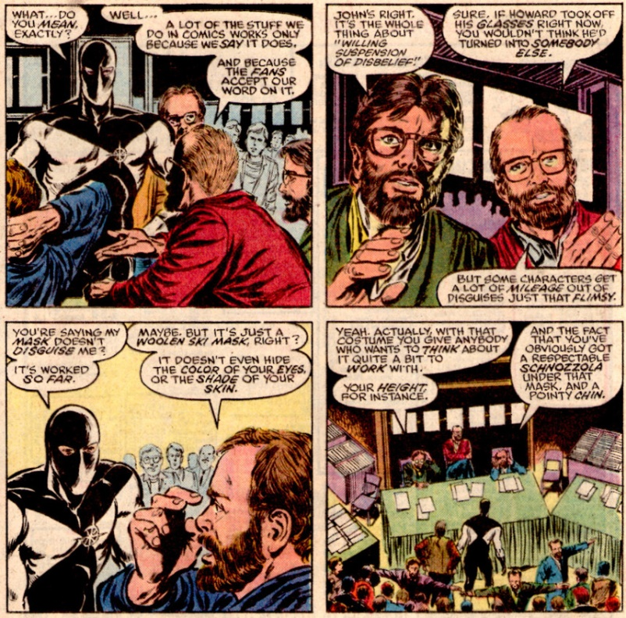

the two comics creators argue, somewhat obliquely, that the very notion of realism in superhero comics can’t possibly work. In essence, the reader wants the fantastic and is willing to look past the inconsistencies to get it.

As time progressed, a central set of circumstances, many of which seem derivative of other works, were contrived to bring the various storylines into closer communion, presumably to partially bolster sales and to partially allow the creative teams to do things they couldn’t in the regular Marvel brand.

The Russian invasion of Afghanistan, which was also being discussed in [*Watchmen*](https://en.wikipedia.org/wiki/Watchmen), made for the volatile geopolitical backdrop needed for the World War III finale that brought the NU to a close. The destruction of the city of Pittsburgh by the thoughtless actions of Star Brand is the trigger for the conflict. The United States Government, assuming that the event is a terrorist action carried out by paranormals from another country (possible the Soviets) reinstitutes a draft with a special emphasis on acquiring paranormals to strike back. The entire plot line is nearly identical in its visuals and big-picture structure to the destruction of Tokyo in [*Akira*](https://en.wikipedia.org/wiki/Akira_(manga)) and the world war that follows. The build-up of forces (conventional and paranormal) and accompanying tensions eventually cascade into open hostilities which then escalate into outright war. The war is ultimately stopped by the intervention of a star child in nearly the same fashion as was seen in the 1984 movie [*2010: The Year We Made Contact*](http://www.imdb.com/title/tt0086837/?ref_=nv_sr_1).

Since the threads of all 8 books and 3 graphic novels are interwoven, it isn’t possible to review each series in a standalone fashion. The order in which they will be presented is, perhaps, the most logical one that can be achieved. The short-lived books will be discussed first with special note being made as to how these stories and their main characters transition into the larger back drop of World War III. Finally, the longer runs will be reviewed in conjunction with those graphic novels that have the best overlap with the central story thread. Specifically, *D.P. 7* and *The Draft* will form one unit while *Star Brand*, *The Pitt*, and *The War* will form the other.

In the next installment, *New Universe: Part 2 – The Supporting Books*, the four smaller runs, which set the stage for the War will be reviewed.

## Kickers Inc.

The first of the short-lived books and definitely the weakest in terms of premise and overall storyline was *Kickers Inc.*, sported 8 different writers over its 12-issue run.

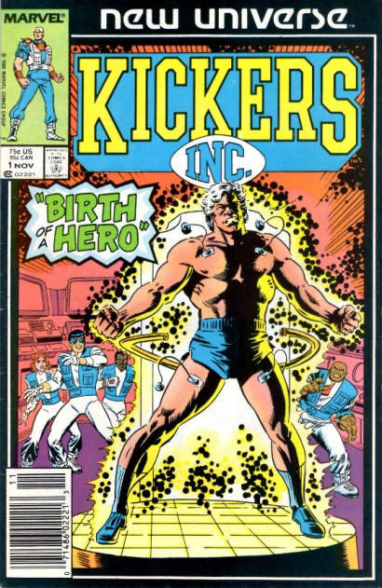

The plot line followed the star quarterback of the New York Smashers, Jack Magniconti, who acquires super-human speed, endurance, and strength. The original explanation offered, at least to the characters within the framework, is that Jack’s brother has exposed him to a state-of-the-art performance enhancing substance, although later Jack’s power is attributed to the White Event.

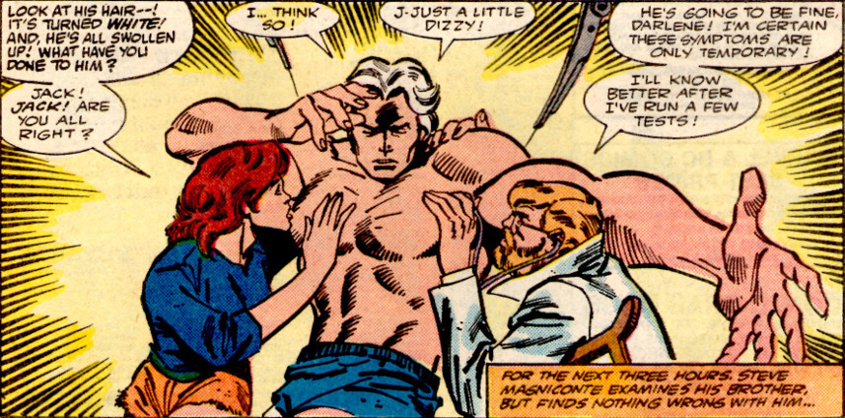

The series never got its legs underneath it and the reader was left wondering what there was to care about and how it had anything to do with the world outside his window. After his metamorphosis, Magniconti founds a non-profit aid group comprised of himself, his wife, and three of his teammates. Their aim was to help people who had nowhere else to turn. This idea never panned out and the trajectory of the story ping-ponged between the group, Jack’s guilt over having an unfair advantage on the gridiron, and a ludicrous situation where the owner of the team, a vindictive harpy, plays Jack in tennis match to decide the fate of the team. *Kickers Inc.* finally settled in on a much grimmer plot where the footballers are played by the CIA into doing their dirty work.

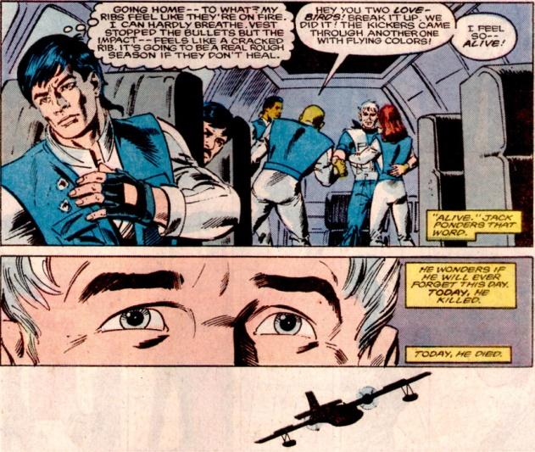

These events later set the stage Captain Magniconti being at the forefront of the paranormal soldiers who were drafted to fight in the World War III events that unfold at the end of the NU line.

## Mark Hazzard: Merc

Initially conceived and written by Peter David, *Mark Hazzard: Merc* was the odd-man out of all of the NU books. There was no tie-in with the White Event and the stories, while interesting at times, offered nothing in terms of science fiction, being centered on the attempts to balance work and home life of the titular character.

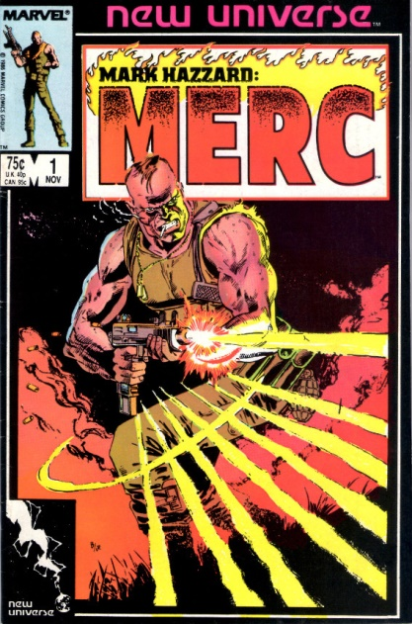

At times, its depiction of war was downright silly,

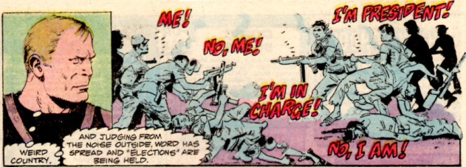

but eventually the series started to deal honestly with the costs of war. The book also features one of the most unusual moves ever published – the death of the main character before the end of this 12-issue series. In the annual published between issues 11 and 12, a mortally wounded Mark Hazzard is taken off life support and allowed to die peacefully in his sleep

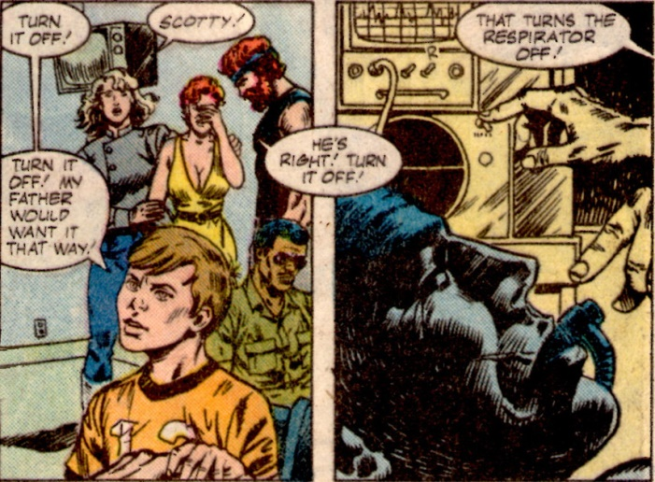

The only lasting feature of the book was the introduction of the Afghan conflict as a central plot point that would be knitted into the World War III scenario.

## Spitfire and the Troublemakers

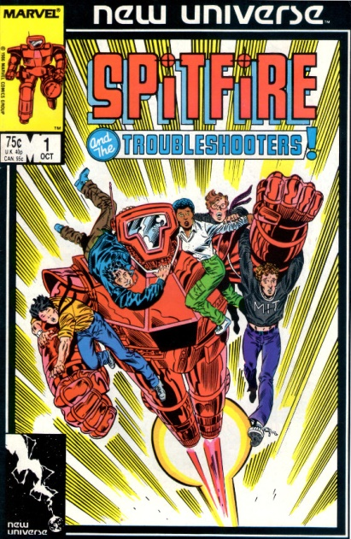

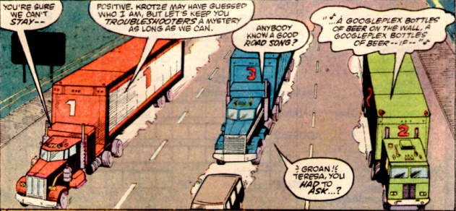

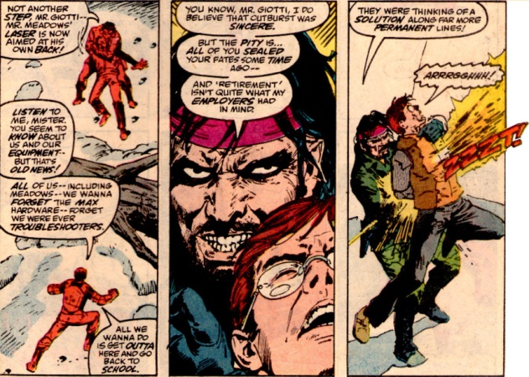

## Nightmask

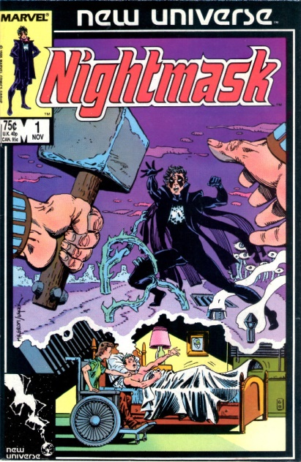

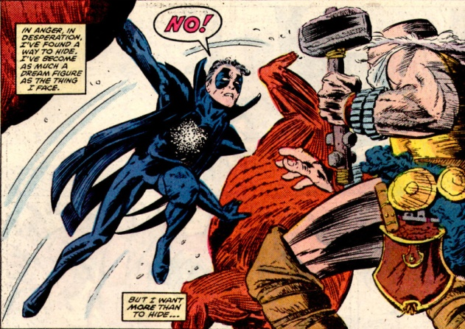

## Jvstice

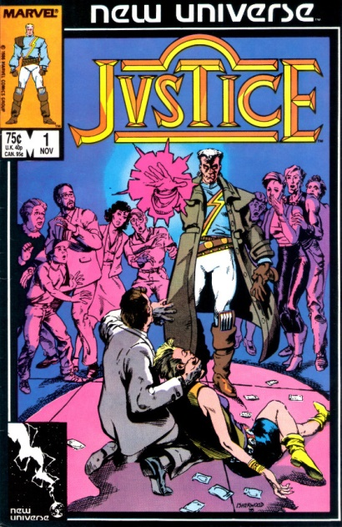

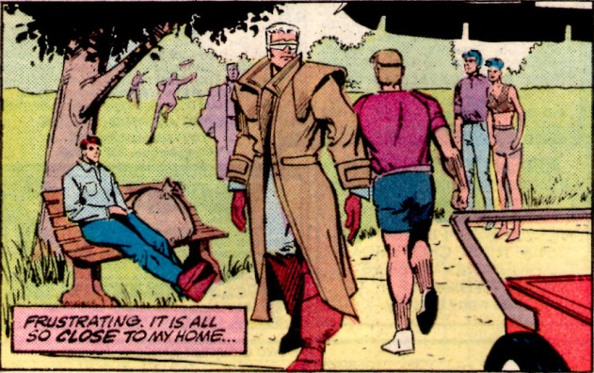

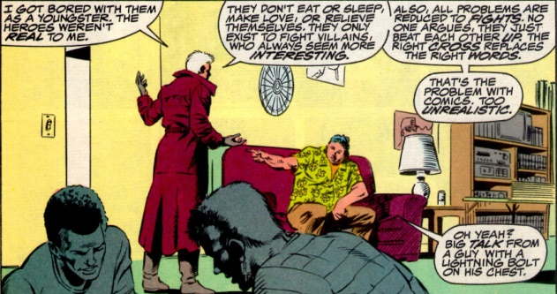

## Psi-Force

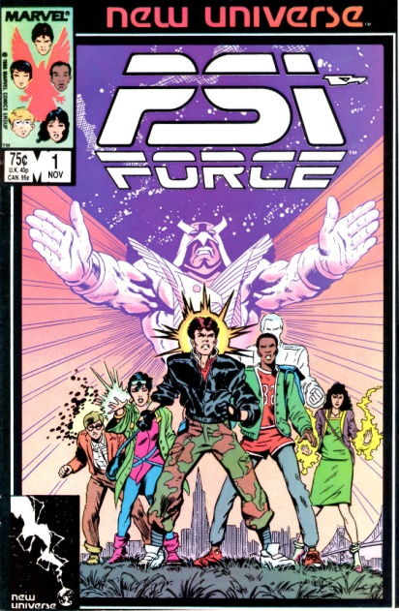

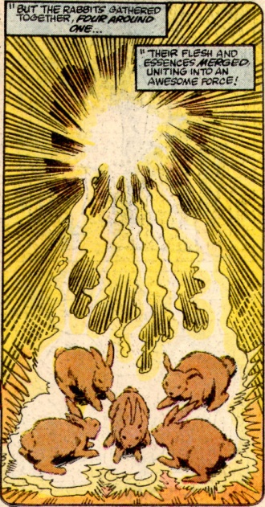

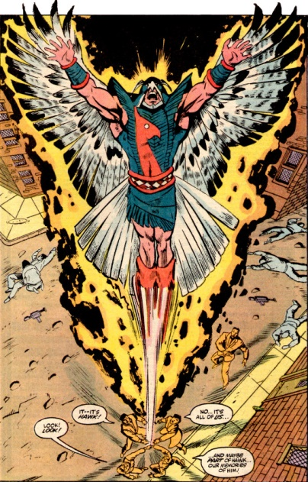

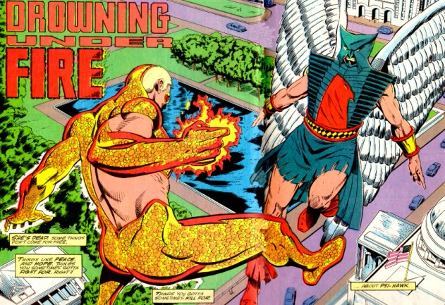

## D.P. 7

Perhaps the most stable of the NU offerings, D.P. 7 followed the lives of various paranormals who had

